

COURSE: (CL-1004) OBJECT ORIENTED PROGRAMMING LAB

LAB TASK # 2 WEIGHTAGE: 2

**NOTE:**

Only submit .cpp file of each question in a folder. Anyone who submits any other format file will get straight **ZERO.** Each question should have a separate .cpp file. Copy Paste or other UFM will also get **ZERO**. Use the following format for naming the folder Roll#_Name (P18-1234_NAME).

**QNo.01:** Write a program that takes two numbers from the user and perform all arithmetic operations.

1. Addition
2. Subtraction
3. Division
4. Multiplication
5. Remainder

**Note:** Take values from user at runtime using cin

**Q No.2:** Write a program in C++ that ask a user to enter radius and calculate the volume of a sphere. After calculating the volume, print the output on screen.

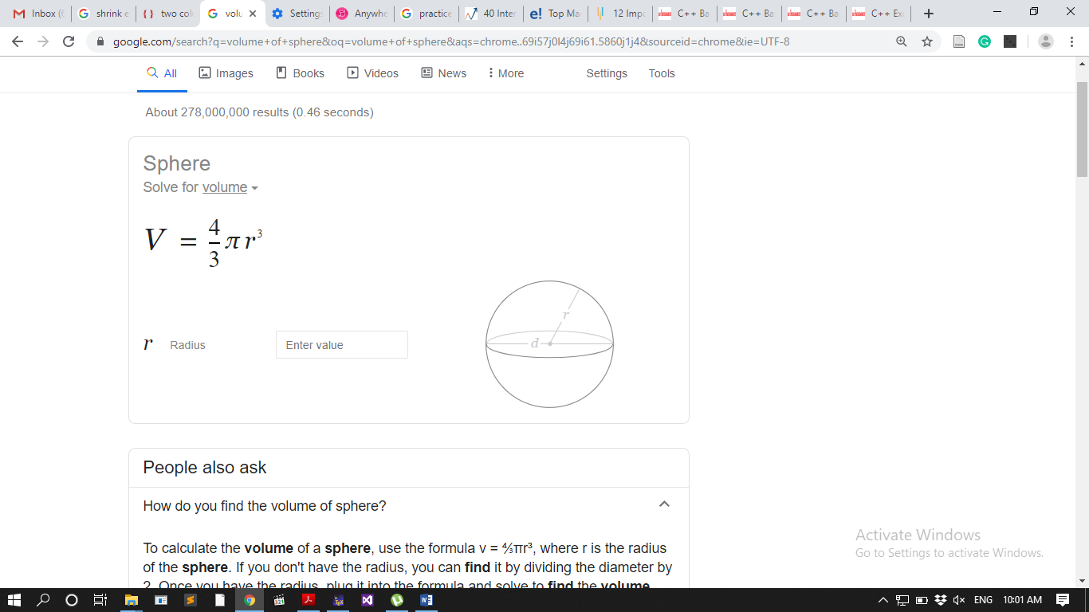

**Note:** Take values from user at runtime using cin

**Q No.03**: Ask user to enter a three-digit number and then display the number in reverse order.